PEI MUSEUM AND HERITAGE FOUNDATION
A proposal to Provide Storage at the Orwell Corner Historic Village
For
Agricultural Equipment Made in PEI

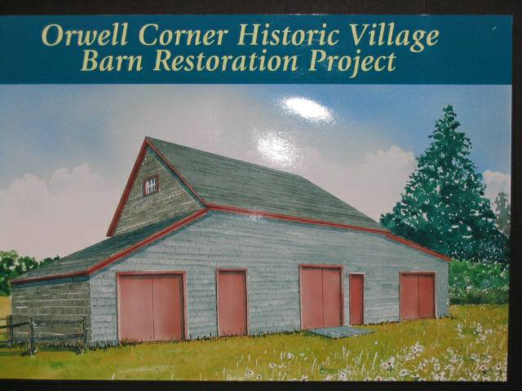
Artist’s rendering of the building including additions

Orwell corner Historic Village has been designated by the Province for its major display of agricultural equipment and a new display and visitor centre was constructed at that site in 200xx. Some Island-made agricultural equipment is included in the display, however, the Museum has other Island made artifacts not on display and is aware of many others either in the hands of private collectors or disappearing from their current resting places – forests, hedgerows and rapidly deteriorating barns.

The Prince Edward Island Museum and Heritage Foundation continues to add to its collection and, if space could be found, would mount a permanent display of Island –made equipment in a prominent location on the museum grounds. The search for both additional Island-made equipment and additional space has been facilitated by the Community Foundation of Prince Edward Island.

More specifically, the PEI Museum and Heritage Foundation proposes to:

- Designate an existing barn located on the Museum property for the purpose of displaying Island made farm equipment. The barn is ideally located being the first building encountered after a visitor exits the visitor centre and starts a tour of the grounds.
- The barn is a typical small pitched-roof barn measuring 26 by 36 feet with both roof and walls clad in eastern cedar shingles. In addition to fixing up the barn, the PEI Museum and Heritage foundation proposes to double the footprint by adding a shed measuring 18 x 26 feet at each end thus providing 1872 sq feet of ground level space. A small amount of storage space will be available on the second floor of the original building.
- Renovations to the barn include new sills, new framing as required, cedar shingles on roof and walls and new doors. The floor will be gravel with a layer of polyethylene beneath
- The renovations will include minor landscaping and upgraded gravel paths.

